CISC 332

QBnB Project Deliverable 3

Zachary Baum 10090150

Vinyas Harish 10089169

March 31st, 2016

Table of Contents

[Continued Assumptions 1](#_Toc447204026)

[Entity Relationship Diagram 3](#_Toc447204027)

[Relational Schema 4](#_Toc447204028)

[Table Dumps 6](#_Toc447204029)

[SQL Statements & Sample Outputs 9](#_Toc447204030)

[Generic Statements - by User 9](#_Toc447204031)

[MEMBER 9](#_Toc447204032)

[OWNER 9](#_Toc447204033)

[CONSUMER 10](#_Toc447204034)

[ADMIN 11](#_Toc447204035)

[Demo Statements - by User 12](#_Toc447204036)

[MEMBER 12](#_Toc447204037)

[OWNER 13](#_Toc447204038)

[CONSUMER 14](#_Toc447204039)

[ADMIN 17](#_Toc447204040)

[State Machine Diagram 20](#_Toc447204041)

[Discussion 21](#_Toc447204042)

[Project Overview 21](#_Toc447204043)

[Core Functionality Achieved 21](#_Toc447204044)

[All Members: 21](#_Toc447204045)

[Owners: 21](#_Toc447204046)

[Consumers: 21](#_Toc447204047)

[Administrators: 21](#_Toc447204048)

[Design and Implementation Decisions 22](#_Toc447204049)

[Design 22](#_Toc447204050)

[Implementation 24](#_Toc447204051)

[Technologies and Tools Used 24](#_Toc447204052)

[Languages 24](#_Toc447204053)

[Technologies & Frameworks Used: 25](#_Toc447204054)

[Problems Faced 28](#_Toc447204055)

[Critical Reflection and Future Development Possibilities: 29](#_Toc447204056)

[What could have been done as well? 29](#_Toc447204057)

[Using GitHub further: 29](#_Toc447204058)

[Managing communication through Slack: 29](#_Toc447204059)

[Getting external feedback sooner: 29](#_Toc447204060)

[What could have been improved? 30](#_Toc447204061)

[Assumptions we could have worked beyond 30](#_Toc447204062)

[Extra features 30](#_Toc447204063)

[User Guide 32](#_Toc447204064)

[Logging in & signing up 32](#_Toc447204065)

[Consumer Dashboard 33](#_Toc447204066)

[Supplier Dashboard 34](#_Toc447204067)

[Admin Guide 36](#_Toc447204068)

# Continued Assumptions

1. We have used Member\_ID as the primary key for our Member table, restricting each email to being associated with one account on QBnB. We are assuming since this is a Queen’s alumni database we will not have an integer overflow with the number of registered users.
2. Users will not enter invalid information or forms that are incomplete when using our application.
3. All Properties in the Property table must be owned by some member of QBnB.
4. One member may own multiple properties, but multiple members cannot own the same property.
5. Each property belongs to one and only one district, but a district may encompass multiple properties.
6. All bookings must be approved (or denied). Users can only cancel bookings if they are “pending”. All bookings are for one week in duration.
7. The member that owns a rentable property is able to approve (or deny) any bookings, and all bookings need only be approved once.
8. Owner\_ID corresponds to the Member\_ID of the owner of the property in question.
9. Any member may comment as many times as they want on a property, but the owner of the property is the only user who may reply directly to those comments on their property.
10. In order to comment on a property, a member must have booked it at some point in time. The property being commented on must exist.
11. Administrator accounts will be limited to five, and will be the first five accounts created in the Member table (Member\_IDs 1, 2, 3, 4 and 5).
12. When leaving feedback on a property, a comment is required, but a rating (out of five) is optional.
13. An average rating will only be shown if the property being shown has at least one rating given to it.
14. When in the user dashboard, administrators will have the same abilities as an equivalent user (consumer if they do not own any properties or supplier if they own at least one).
15. Any fields can be updated by a member except for the Member\_ID.
16. A property is available for booking if and only if there is no booking for it listed at that time, or the booking(s) that is/are currently made on it are listed as rejected or pending for that time.
17. Any fields can be updated to a property except for the Property\_ID.
18. When deleting an accommodation, the comments and bookings associated with it are also deleted.
19. When deleting a user account, all properties and the comments and bookings with those properties are deleted.
20. Due to the fast-paced nature of our version of QBnB, users are only able to book properties in the span of the next month.
21. The only districts available are in Toronto for the current version to limit complexity and to keep the district list short.
22. Users cannot edit comments; owners are unable to edit their replies.
23. There are a limited number of selectable features, and users are unable to create their own custom features, at this time.
24. For demonstration purposes, users are able to leave comments before their booking has been completed.

# Entity Relationship Diagram

**Legend:**

D 🡪 Discriminator

PK 🡪 Primary Key

# Relational Schema

CREATE DATABASE QBnB;

USE QBnB;

CREATE TABLE Member(

Member\_ID int NOT NULL AUTO\_INCREMENT,

F\_Name varchar(20) NOT NULL,

L\_Name varchar(20) NOT NULL,

Email varchar(50) NOT NULL,

Phone\_No bigint(15) NOT NULL,

Grad\_Year int(4) NOT NULL,

Faculty varchar(50) NOT NULL,

Degree\_Type char(10) NOT NULL,

Password varchar(180) NOT NULL,

PRIMARY KEY (Member\_ID),

UNIQUE (Email)

);

CREATE TABLE District(

District\_Name varchar(50) NOT NULL,

PRIMARY KEY (District\_Name)

);

CREATE TABLE POI(

District\_Name varchar(50) NOT NULL,

POI\_Name varchar (50) NOT NUll,

POI\_Description varchar(500) DEFAULT NULL,

PRIMARY KEY (District\_Name, POI\_Name),

FOREIGN KEY (District\_Name) references District(District\_Name) ON UPDATE CASCADE ON DELETE CASCADE

);

CREATE TABLE Property(

Property\_ID int NOT NULL AUTO\_INCREMENT,

Owner\_ID int NOT NULL,

Street\_No int NOT NULL,

Street\_Name varchar(30) NOT NULL,

City varchar(30) NOT NULL,

Country varchar(30) NOT NULL,

Postal\_Code varchar(10) NOT NULL,

District\_Name varchar(30) NOT NULL,

Type varchar(15) NOT NULL,

Price decimal NOT NULL,

PRIMARY KEY (Property\_ID),

FOREIGN KEY (District\_Name) references District(District\_Name) ON UPDATE CASCADE ON DELETE CASCADE,

FOREIGN KEY (Owner\_ID) references Member(Member\_ID) ON UPDATE CASCADE ON DELETE CASCADE

);

CREATE TABLE Feature(

Property\_ID int NOT NUll,

Feature\_Name varchar(100) NOT NULL,

Feature\_Description varchar(500) DEFAULT NUll,

PRIMARY KEY (Property\_ID, Feature\_Name),

FOREIGN KEY (Property\_ID) references Property(Property\_ID) ON UPDATE CASCADE ON DELETE CASCADE

);

CREATE TABLE Booking(

Booking\_ID int NOT NULL AUTO\_INCREMENT,

Property\_ID int NOT NULL,

Member\_ID int NOT NULL,

Owner\_ID int NOT NULL,

Booking\_Start datetime NOT NULL,

Booking\_Status char(15) NOT NULL,

PRIMARY KEY (Booking\_ID, Property\_ID, Member\_ID),

FOREIGN KEY (Property\_ID) references Property(Property\_ID) ON UPDATE CASCADE ON DELETE CASCADE,

FOREIGN KEY (Member\_ID) references Member(Member\_ID) ON UPDATE CASCADE ON DELETE CASCADE,

FOREIGN KEY (Owner\_ID) references Property(Owner\_ID) ON UPDATE CASCADE ON DELETE CASCADE

);

CREATE TABLE Comment(

Booking\_ID int NOT NUll,

Comment\_Time timestamp NOT NULL DEFAULT CURRENT\_TIMESTAMP ON UPDATE CURRENT\_TIMESTAMP,

Member\_ID int NOT NULL,

Rating int DEFAULT NULL,

Comment\_Text varchar(500) NOT NULL,

Owner\_Reply varchar(500) DEFAULT NULL,

PRIMARY KEY (Booking\_ID, Comment\_Time),

FOREIGN KEY (Booking\_ID) references Booking(Booking\_ID) ON UPDATE CASCADE ON DELETE CASCADE,

FOREIGN KEY (Member\_ID) references Member(Member\_ID) ON UPDATE CASCADE ON DELETE CASCADE

);

# Table Dumps

Property



Point of Interest



Comment



Feature



Booking



District



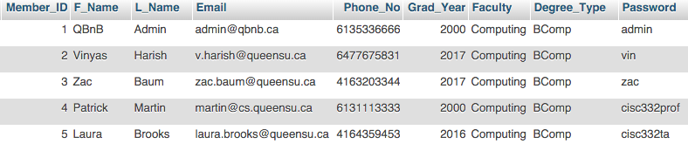Member

# SQL Statements & Sample Outputs

## Generic Statements - by User

### MEMBER

#Register as member

INSERT INTO `Member` (`F\_Name`,`L\_Name`,`Email`,`Phone\_No`,`Grad\_Year`,`Faculty`,`Degree\_Type`,`Password`,`Member\_ID`)

VALUES('value1','value2','value3',value4,value5,'value6','value7','value8',value9)

#Update anything in profile

UPDATE `Member`

SET attribute1 = value1, ...

WHERE Member\_ID = theirMemberID

#Sign a member in

SELECT Member\_ID

FROM `Member`

WHERE Email = theirEmailID AND Password = theirPassword

#Remove their membership

DELETE FROM `Member`

WHERE Member\_ID = theirMemberID

### OWNER

#Create new accommodation

INSERT INTO `Property` (`Street\_No`,`Street\_Name`,`City`,`Country`,`Postal\_Code`,`District\_Name`,`Type`,`Price`,`Property\_ID`,`Owner\_ID`)

VALUES (value1,'value2','value3','value4','value5','value6','value7', value8, value9)

#Update existing accommodation

UPDATE `Property`

SET attribute1 = value1, ...

WHERE Property\_ID = thePropertyID

#Remove accommodation

DELETE FROM `Property`

WHERE Property\_ID = thePropertyID

#Approve booking

UPDATE `Booking`

SET Booking\_Status = 'Approved'

WHERE Booking\_ID = theBookingID AND Booking\_Start = theBookingStart

#Reject booking

UPDATE `Booking`

SET Booking\_Status ='Rejected'

WHERE Booking\_ID = theBookingID AND BookingStart = theBookingStart

#Reply to comment

UPDATE `Comment`

SET Owner\_Reply = ownerCommentText

WHERE Member\_ID = commentersMemberID AND Booking\_ID = theBookingID AND Comment\_Time = theCommentTime

#List all owned properties + comments / ratings

SELECT Street\_No, Street\_Name, City, Price, Property.Property\_ID, Comment\_Text, Rating, Owner\_Reply

FROM Property

LEFT JOIN (`Comment` NATURAL JOIN `Booking`)

ON Property.Property\_ID = Booking.Property\_ID

#Add feature to property

INSERT INTO `Feature`(Property\_ID, Feature\_Name, Feature\_Description)

VALUES (Value1, "Value2","Value3”)

### CONSUMER

#Search by district

SELECT DISTINCT Street\_No, Street\_Name, City, Country, District\_Name, Type, Price, Property\_ID

FROM Property

WHERE District\_Name = selectedDistrict

#Search by type

SELECT DISTINCT Street\_No, Street\_Name, City, Country, District\_Name, Type, Price, Property\_ID

FROM Property

WHERE Type = selectedType

#Search by features

SELECT DISTINCT Street\_No, Street\_Name, City, Country, District\_Name, Type, Price, Property\_ID

FROM Property NATURAL JOIN Feature

WHERE Feature\_Name = selectedFeature

#Search by price

SELECT DISTINCT Street\_No, Street\_Name, City, Country, District\_Name, Type, Price, Property\_ID

FROM Property

WHERE Price <= maxPriceEntered AND Price >= minPriceEntered

#List all ratings and comments for a listing

SELECT DISTINCT Property\_ID, Comment\_Text, Owner\_Reply, Rating

FROM Comment NATURAL JOIN Booking

WHERE Booking.Property\_ID = thePropertyID

ORDER BY Comment\_Time

#List availability of rental

SELECT Booking\_ID, Booking\_Status

FROM Booking

WHERE Booking\_Start = currentWeekStart AND Property\_ID = thePropertyID AND (Booking\_Status = "Approved")

#Show owner details

SELECT DISTINCT F\_Name, L\_Name, Email, Phone\_No

FROM Member NATURAL JOIN Property

WHERE Member\_ID = ownerOfSelectedProperty

#Place booking request

INSERT INTO `Booking` (`Property\_ID`,`Booking\_Start`,`Booking\_Status`,`Member\_ID`,`Owner\_ID`)

VALUES (value1, value2,'Pending',value3,value4)

#List all bookings by one member

SELECT Booking\_ID, Member\_ID, Property\_ID, Street\_No, Street\_Name, City, Booking\_Start, Booking\_Status

FROM Booking NATURAL JOIN Property

WHERE Member\_ID = theMemberID

GROUP BY Booking\_Status

ORDER BY Booking\_Start

#Show details of one booking

SELECT DISTINCT Street\_No, Street\_Name ,City, District\_Name, Type, Price, Booking\_Start, Booking\_Status, Owner\_ID

FROM Booking NATURAL JOIN Property

WHERE Booking\_ID = consumerMemberID AND Property\_ID = thePropertyID

#Add comment and rating for an accommodation

INSERT INTO `Comment` (`Member\_ID`,`Property\_ID`,`Rating`,`Comment\_Text`)

VALUES (commenterMemberID, thePropertyID, ratingValue, 'commentText')

#Cancel a booking

DELETE FROM `Booking`

WHERE Booking\_ID = theBookingID

### ADMIN

#Delete a member and associated listings

DELETE FROM `Member`

WHERE Member\_ID = theirMemberID

#Delete an accommodation

DELETE FROM `Property`

WHERE Property\_ID = thePropertyID

#Summarize bookings and ratings per accomodation

SELECT Booking\_Start, Booking\_Status, Avg(Rating)

FROM Booking NATURAL JOIN Comment

WHERE Property\_ID = thePropertyID

GROUP BY Booking\_Status

ORDER BY Booking\_Start

#Summarize bookings and ratings per owner

SELECT Booking\_Start, Booking\_Status, Avg(Rating)

FROM Booking NATURAL JOIN Comment

WHERE Owner\_ID = supplierMemberID

GROUP BY Booking\_Status

ORDER BY Booking\_Start

#Summarize booking activity per customer

SELECT Booking\_Start, Booking\_Status

FROM Booking

WHERE Member\_ID = customerMemberID

GROUP BY Booking\_Status

ORDER BY Booking\_Start

## Demo Statements - by User

Note that the timestamps on comments may vary from those shown in the original table dumps because the database sometimes had to be dropped as part of the process in order to get the queries working.

### MEMBER

1. #Register new member

INSERT INTO `Member` (`F\_Name`,`L\_Name`,`Email`,`Phone\_No`,`Grad\_Year`,`Faculty`,`Degree\_Type`,`Password`)

VALUES ('Elon','Musk','e.musk@tesla.com',4567866787,1985,'Commerce','BComm','money')



1. #Update anything in profile

UPDATE `Member`

SET Password = 'cash'

WHERE Member\_ID = 6



1. #Sign in

SELECT Member\_ID

FROM `Member`

WHERE Email = 'e.musk@tesla.com' AND Password = 'cash'



1. #Cancel membership

#Note: Elon Musk was still in the table prior to this statement

DELETE FROM `Member`

WHERE Member\_ID = 6



### OWNER

1. #Create new property

INSERT INTO `Property` (`Street\_No`,`Street\_Name`,`City`,`Country`,`Postal\_Code`,`District\_Name`,`Type`,`Price`,`Owner\_ID`)

VALUES (15,'Wynd Drive','Toronto','Canada','M7T G6H','Forest Hill','House',1000, 2)



1. #Update existing property information

UPDATE `Property`

SET Price = 1500

WHERE Property\_ID = 6



1. #Delete property

DELETE FROM `Property`

WHERE Property\_ID = 6



1. #Approve booking

UPDATE `Booking`

SET Booking\_Status = 'Approved'

WHERE Property\_ID = 4 AND Booking\_Start = "2016-06-11 12:30:00"



1. #Reject booking

UPDATE `Booking`

SET Booking\_Status='Rejected'

WHERE Booking\_ID = 2 AND Booking\_Start = "2016-06-11 12:30:00"



1. #Reply to comment

UPDATE `Comment`

SET Owner\_Reply = "Glad you liked it!"

WHERE Member\_ID = 3 AND Booking\_ID = 5 AND Comment\_Time = "2016-03-08 22:33:41"



#List all owned properties with comments

SELECT Street\_No, Street\_Name, City, Price, Property.Property\_ID, Comment\_Text, Rating, Owner\_Reply

FROM Property

LEFT JOIN (`Comment` NATURAL JOIN `Booking`)

ON Property.Property\_ID = Booking.Property\_ID



#Add feature to property

INSERT INTO `Feature`(Property\_ID, Feature\_Name, Feature\_Description)

VALUES (3, "Basketball court","The floors of the basketball court are also mahogany!")



### CONSUMER

#Search by district

SELECT DISTINCT Street\_No, Street\_Name, City, Country, District\_Name, Type, Price, Property\_ID

FROM Property

WHERE District\_Name = "Entertainment District"



#Search by type

SELECT DISTINCT Street\_No,Street\_Name,City,Country,District\_Name,Type,Price,Property\_ID

FROM Property

WHERE Type = "Loft"



#Search by feature

SELECT DISTINCT Street\_No, Street\_Name, City, Country, District\_Name, Type, Price, Property\_ID

FROM Property NATURAL JOIN Feature

WHERE Feature\_Name = "Basketball court"



1. #Search by price

SELECT DISTINCT Street\_No, Street\_Name, City, Country, District\_Name, Type, Price, Property\_ID

FROM Property

WHERE Price <= 75 AND Price >= 15



1. #List all ratings and comments for a listing

SELECT DISTINCT Property\_ID, Comment\_Text, Owner\_Reply, Rating

FROM Comment NATURAL JOIN Booking

WHERE Booking.Property\_ID = 5

ORDER BY Comment\_Time



1. #List availability of rental

SELECT Booking\_ID, Booking\_Status

FROM Booking

WHERE Booking\_Start = "2016-06-11 12:30:00" AND Property\_ID = 4 AND (Booking\_Status = "Approved")



1. #Provide owner details

SELECT DISTINCT F\_Name, L\_Name, Email, Phone\_No

FROM Member NATURAL JOIN Property

WHERE Member\_ID = 2



1. #Place booking request

INSERT INTO `Booking` (`Property\_ID`, `Booking\_Start`, `Booking\_Status`, `Member\_ID`, `Owner\_ID`)

VALUES (2, '2016-08-17 16:30:00', 'Pending', 5, 2)



1. #List all bookings for one Member

SELECT Booking\_ID, Member\_ID, Property\_ID, Street\_No, Street\_Name, City, Booking\_Start, Booking\_Status

FROM Booking NATURAL JOIN Property

WHERE Member\_ID = 3

GROUP BY Booking\_Status

ORDER BY Booking\_Start



1. #Get details on one booking

SELECT DISTINCT Street\_No, Street\_Name, City, District\_Name, Type, Price, Booking\_Start, Booking\_Status, Owner\_ID

FROM Booking NATURAL JOIN Property

WHERE Booking\_ID = 1 AND Property\_ID = 5



1. #Comment on booking

INSERT INTO `Comment` (`Booking\_ID`,`Member\_ID`,`Rating`,`Comment\_Text`)

VALUES (6,5,5,'Never wanted to leave! Wonderful home.')



1. #Delete booking

DELETE FROM `Booking`

WHERE Booking\_ID = 5



### ADMIN

1. #Delete member and associated listings

DELETE FROM `Member`

WHERE Member\_ID = 4











1. #Delete property

DELETE FROM `Property`

WHERE Member\_ID = 5











1. #Summarize bookings and ratings per property

SELECT Booking\_Start, Booking\_Status, Avg(Rating)

FROM Booking NATURAL JOIN Comment

WHERE Property\_ID = 4

GROUP BY Booking\_Status

ORDER BY Booking\_Start



1. #Summarize bookings and ratings per supplier

SELECT Booking\_Start, Booking\_Status, Avg(Rating)

FROM Booking NATURAL JOIN Comment

WHERE Owner\_ID = 4

GROUP BY Booking\_Status

ORDER BY Booking\_Start



1. #Summarize bookings and ratings per customer

SELECT Booking\_Start, Booking\_Status

FROM Booking

WHERE Member\_ID = 2

GROUP BY Booking\_Status

ORDER BY Booking\_Start



# StatechartDiagram_V4.pdfState Machine Diagram

**NOTE**: The Supplier Dashboard, User Dashboard, Create Property, and Update Property pages are considered to be a part of the entire “Dashboard” state, though they occupy different views in the actual website. Therefore, any state entering or leaving all “Dashboard” states is shared to reduce the number of transitions to states such as the Settings Page state, Exit Website state and Admin Dashboard state.

# Discussion

## Project Overview

The goal of this project was to design and implement a fully functional, web-hosted database application known as The Queen’s Alumnae Bed and Breakfast service (QBnB). QBnB consists of two parts, a server-side (relational database) and client-side (web-application). QBnB will allow for alumnae who intend to travel to a city to be matched with alumnae who are willing to rent out their properties in that city. There are three types of users for QBnB: consumers, owners, and administrators. Owners will register properties on the site with several predefined features in a predefined district within a city. Consumers will use QBnB to search for properties in various districts of the city of interest and then submit a booking request to an owner to rent the property for one week. Owners can then accept or deny the booking and once the booking has been accepted, consumers can leave a comment and rating on the property.

## Core Functionality Achieved

We were able to successfully implement all the minimum required functionality for QBnB. The core functionalities for each type of member are listed below:

### All Members:

* Register for QBnB
* Update profile
* Cancel membership

### Owners:

* List a new property
* Remove or edit an existing property
* List properties
* Submit confirmation or reject a booking
* Reply to a comment

### Consumers:

* Search properties by district, type, features, price
* List all the ratings and comments for a property
* List the availability of a property
* Request a booking
* List all a consumer’s bookings (past, present, and upcoming)
* Add a comment (and optional rating) for one of their booked properties
* Cancel a booking

### Administrators:

* Summarize bookings and ratings per property
* Summarize bookings and ratings per supplier
* Summarize booking activity per customer
* Delete a property and all of its associated bookings and comments
* Delete a member and of their associated properties, bookings, and comments

## Design and Implementation Decisions

### Design

#### Landing Page

When new users first enter our website, they find a colourful and welcoming landing page. It was important for us that users found all the information that they needed about QBnB right from the landing page. With our brief description of the QBnB service, “Find Houses. Rent from Alumni.”, right above a registration field and button, users can jump right into our site. If users want more information, scrolling the page provides more details followed by another registration field and button for convenience at the bottom.

If users have already registered in the past, we provide a convenient method of signing-in in the top right-hand corner of the page.

#### Registering and Signing In

We decided to split the views for the registration and sign-in pages in order to increase the ease of use for the site, and to not clutter a single page with very distinctly different features. However, by providing a link to the sign-in page from the registration page, and vice-versa we ensure that users are not inconvenienced by limited navigation options between pages. Moreover, we wanted to ensure that clicking the QBnB logo allows users to return to our landing page, just in case they wanted to read more about the service before logging-in or registering. Both the registration and sign-in pages are similarly designed and have simple interfaces to ensure that users have a pleasant experience when beginning to interact with our site.

#### Account Management

To promote easy navigation between pages, we have included a navigation bar at the top of every page. This navigation bar remains anchored at the top of the page so that users will always have access to it. The navigation bar allows users to access a page for updating their account or cancelling their membership, to log out, and it also allows users who are administrators to access the “Admin Dashboard”.

By clicking on the “My Account” button, users access a new page that allows them to view and change all the information that they inputted into their registration form. For simplicity, users do not have the ability to change their Member\_ID, as it is kept server-side as a way to organize information across our relations. We decided to display account information in pre-filled forms to allow for convenient editing and the continued use of central design themes through our site. Membership cancellation is handled by a big red button that says exactly what it does; “Delete Account”. We decided to have delete functionality across the service represented in a similar way, with an eye-catching, red colouring to reinforce the gravity of the effects of deleting an account, a booking, or a user’s property.

#### User Dashboard

Once members log in, they are taken to the user dashboard. Because of the sheer number of functions users can perform, we decided to effectively split the user dashboard into two main views, consisting of three pages. The first is a consumer view and the second is an owner view.

Implementing these views as multiple tables seemed to be the obvious way to represent the amount of data associated with available properties and bookings. HTML and CSS would be used to make the table skeleton, and PHP would be used to pull relevant information from the database using MySQL queries to populate the table. However, it was not realistic to show all of the information associated with properties and bookings in a single row since if we merely displayed something similar to the PHPMyAdmin query output view on a query with several joins, users may become overwhelmed and the table would also not look aesthetically pleasing. Thus, we show only crucial information in the tables and JavaScript was used to hide and display extra content by clicking on the table row of the property of interest.

In the properties table, clicking on a row opens an extended view of given property where users can see details regarding the owner, features of the property, ratings, comments and points of interest nearby in the district. In this extended view, users can also book a property. By clicking on the “Book me!” button, users are shown a list view where vacant weeks are shown in green and booked weeks are shown in red and are not clickable by the user.

The bookings table was also governed by similar design principles, as we only showed crucial summary information about the booking in the table and do not display other details from users unless they clicked on various table cells to access further information. In order to display this information, we used a popover effect from the Bootstrap framework. Clicking on the address cell gave details on the type of the property and its features while clicking on the owner cell provides the owner’s contact information. Another important feature of the bookings table is the review cell. A message bubble icon indicates that the user has already commented on a booking and can view their comment and rating, if they chose to leave a rating. A pencil and pad icon indicated to the user that they can still leave a comment and rating. The commenting and rating system, like other cells in the table, utilizes a popup that houses a form for typing a comment and slider to leave a rating. With some simple CSS, we were able to animate a 5-star slider to add some colour to the site. If a user has not made any bookings, they see the skeleton of the booking table with a friendly message encouraging them to explore properties and try booking one they are interested in.

#### Administrator Dashboard

Once administrators log into the website, they can access the “Admin Dashboard” from the navigation toolbar. In fact, we only show the administrator dashboard button to users who are administrators so that normal users would not be confused or mislead in anyway during their interactions with the site. The admin dashboard consists of two main table elements, one summarizing members and the other summarizing properties. Both tables allow the administrator to easily delete a member or property by clicking the red X button.

Summarizing both consumer and owner details were functional requirements of the QBnB service, however we decided to separate these summaries through the use of popovers as to not overwhelm users with two sets of information that are not overtly related.

Clicking on the user’s name summarizes the user’s details as a consumer. The consumer history popover displays the user’s contact information as well as their booking history. We decided to only generate popovers summarizing owner details for those users that owned property, and made it obvious which users were property owners by showing an extra column with a simple “yes” or “no” to indicate their status. Clicking on the “yes” text for members that are owners displays a summary of the member’s role is a property owner with details such as their average rating, number of properties they own, and a history of bookings made on their properties. For members who do own property, but have no bookings or comments, we provide a simple message to inform administrators of that as opposed to showing a blank popover view.

Similarly, we display a summary view of all properties registered on the site. Clicking on the property address summarizes the owner information, its average rating, and a history of bookings made on the property. For properties that have no bookings or comments, we provide a simple message to inform administrators of that as opposed to showing a blank popover

### Implementation

#### Server-Side

Various crucial assumptions, other than those specified in the project outline, were made about how the service worked determined the structure of our relational database. Some of these assumptions include restrictions on:

* Property ownership and property geographical constraints,
* Search, booking, and commenting mechanisms,
* The first five members in the database were administrators,
* The cascading effects of deletions and updates,
* Member and property IDs are unable to be changed.

Based on our assumptions, the relational database was organized so that there were seven main relations, two of which were weak entities, as seen in our Entity Relation Diagram. All relationships were implemented in the relational schema as foreign key constraints. The “on update cascade” and “on delete cascade” constraints were used such that deletions of members, properties, bookings, or comments would be reflected in other relations and thus maintain the consistency of the database. In order to facilitate rapid access to various tables, we decided to implement IDs, such as Member\_ID and Property\_ID, as integers; as searching on integers is a much faster operation than searching on strings.

#### Client-Side

We hosted the relational database backend within a web based application front-end guided by the service-oriented (SOA) and model-view-controller (MVC) architectures. Web browsers have become the standard client interface to database servers because they enable large number of users to access the database from anywhere, on multiple platforms. As Javascript and other scripting languages are downloaded and managed by a user’s browser, an aesthetically pleasing and highly functional interface can be provided to any and all browser users. A crucial design goal for our iteration of QBnB was to ensure that our web service was aesthetically pleasing, modern, and highly responsive.

Since QBnB offers a range of services for different types of users, following the principles of SOA and MVC allowed us to loosely couple functionality and yet maximize cohesion between various elements. With our relational database essentially serving as our model, we built views and controllers within our web-application to achieve all of the required functionality. Different views, implemented as separate webpages, are provided to users depending on what type of user they were and, by extension, what functionality they were allowed to have.

## Technologies and Tools Used

### Languages

#### MySQL

MySQL was the tool we used to build the relational database. It is the most popular client server relational database management system used in the world[[1]](#footnote-1), thus there was lots of documentation and support available online that aided us during the development of QBnB. Moreover, since MySQL is a relational database--it has a strong mathematical basis in relational theory and set theory. Because of this mathematical basis, we were able to reason about why the database worked the way it did and could always distill back down to the mathematical theory when we were faced with a problem. We also enjoyed using MySQL because we developed our ER diagram and relational schema before we programmed the implementation and thus always had a guide to look at when we were stuck on implementing certain features.

#### PHP

PHP was the scripting language we used in our website to run our MySQL queries and pull information from our server-side relational database. PHP is embedded within HTML, thus the scripts we wrote were ran on the server and returned HTML results which made displaying them in tables. In terms of the relational database driver, we decided to use PHP’s MySQLi extension as opposed to PHP data objects (PDO). Aside from the fact that we were only shown how to use MySQLi in class, we knew that we did not need to do any object-relational mapping whatsoever but rather just use simple scripts and thus MySQLi served our purposes well. MySQL within PHP itself is depreciated, however we found it quite easy to transition from the MySQL we learned in class to MySQLi.

#### HTML and CSS

HTML was used to make the skeleton of the site and add basic site elements such as tables, text, and buttons. Combined with CSS for adding style to the pages, these two languages allowed us to make the client-side “look and feel” of the web application.

#### JavaScript

JavaScript was used to create the dynamic and animated portions of the web application. Because we used the Bootstrap framework, we needed to include jQuery to facilitate scripting for buttons and create dynamic views. For example, jQuery was needed to display the hidden rows and show extra information in the property table when a user clicked on them.

### Technologies & Frameworks Used:

We had to leverage a wide range of tools and frameworks in order to build a minimum viable product for QBnB. With the exception of Microsoft Visio, we really enjoyed using all of the tools and frameworks. Oftentimes, we picked the most popular tools that programmers use to tackle the problems, thus we got to experience first hand why they are so popular.

#### Microsoft Visio

We originally used Microsoft Visio to draw our ER diagram because generally Microsoft’s productivity suite is believed to have best in class functionality. Microsoft Visio is a tool to create professional flow charts and diagrams and has specific support for software engineering design[[2]](#footnote-2). Although Visio allowed us to make a very aesthetically pleasing ER diagram for the first deliverable, we found its pre-sets confusing to work and it was hard to change any the template diagram to better reflect the structure of ER diagrams that we learned about in class. Moreover, once we made one version of the ER diagram it was extremely difficult to change it. Thus this lead us to move towards another tool, draw.IO for use to prepare diagrams for our second deliverable.

#### draw.io & Google Drive

After a recommendation from a friend who used draw.io[[3]](#footnote-3) in their first deliverable, we decided to move away from Microsoft Visio for our second deliverable. draw.io is an online diagramming tool that is built heavily on Google Drive that allowed us to make an aesthetically pleasing, and easily editable, ER diagram and statechart diagram.

Moreover, since we used Google Drive to manage the creation of our deliverables, draw.io served as a perfect tool that integrated with the rest of our technologies and frameworks used. We especially liked being able to work on documents and diagrams concurrently and still maintain version control to keep track of changes.

#### GitHub

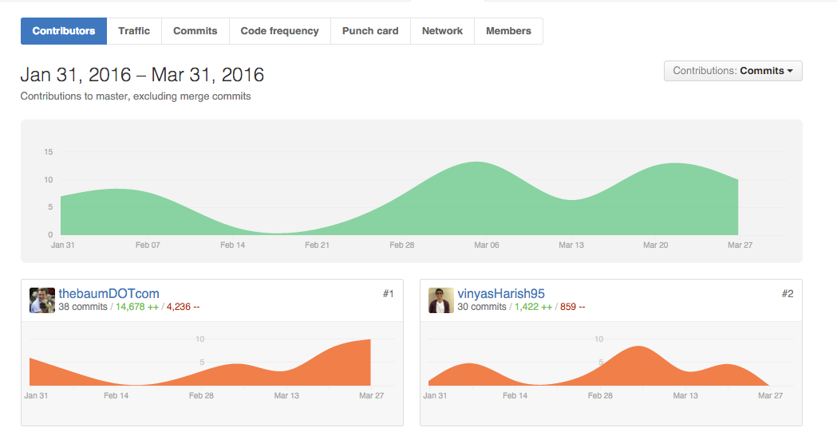Since this project involved a significant amount of programming, we knew from the get-go that maintaining a strong repository and version control system would be crucial to our success. Github[[4]](#footnote-4) is a web-based git repository system that integrates full revision control and source code management along with project management and networking features. Since our team only consisted of two people, we did not need to use multiple branches due to fairly compact amount of functionality we needed in the service. We structured our Git repository around our deliverables, and also made sure to upload the TA’s feedback onto our repository and any other notes to ensure that we really had everything we needed in one place, fully version controlled. One thing about GitHub that we wished we used was the issue and feature tracking features, something that will be explored in detail in the critical reflection section of this report.

**Figure 1**: Commit history over the past three months from both members and the overall project. This is here as Zac’s brag sheet. Source: Github. “8,000 of Zac’s lines are the bootstrap.css… Just saying.” Source: Vinyas Harish.

#### DeliverableImages/Punchcard.pngBootstrap Framework

Figure : 'Punchcard' of the commit history from both members of the project. Isn't Github fun? No coding on Fridays for us. Source: Github.

Bootstrap[[5]](#footnote-5) is an extremely popular, open-source, web design framework that we used to help style and construct our front-end. Some features that made Bootstrap an appealing choice for us during development include its built in support for devices of different shapes and sizes, modern look-and-feel, wide range of custom HTML and CSS components, and jQuery[[6]](#footnote-6) plugins to create dynamic effects and user interaction possibilities.

#### Development Environments

When developing QBnB, we used powerful text editors such as Atom[[7]](#footnote-7) and Sublime Text 2[[8]](#footnote-8) with multilanguage support, and features such as autocomplete, find and replace, and indentation guides, especially helpful for keeping track of our HTML tags! Since we had to host our back-end in a web application, all functionality testing and debugging could be done in a web browser of our choosing. We decided to test on Google Chrome[[9]](#footnote-9), since its been the most popular web browser for almost four years with a cross-platform overall usage of 50%[[10]](#footnote-10).

#### XAMPP

XAMPP[[11]](#footnote-11) was the free-to-use PHP development environment that we used to host our server-side relational database for development and testing. Since it hosts the database locally on the user’s system, users can use Apache and PHP locally. In order to manage and test our database, we used PHPMyAdmin[[12]](#footnote-12). PHPMyAdmin allows users to perform commonly used operations on databases through the user interface but also have direct control via SQL statements. Moreover, we also found setting up our XAMPP server and connecting to our database to be relatively intuitive and user-friendly. Whenever we ran into difficulties using these tools, we were pleased to find significant amounts of detailed documentation available to assist us.

## Problems Faced

Although this project was significant in its size, we did not have many problems in implementing a minimum viable product for QBnB because of our organizational and time management skills, overall work ethic, and good use of software engineering tools and practices.

The sheer amount of functionality needed in the minimum viable product made starting the project intimidating. Moreover, as Vinyas did not have any prior background in website design, we knew that we would have to start the project early in order to successfully design and implement the basic version of QBnB. Because Zac was more well versed in website design from experience in prior classes, we agreed that Vinyas should focus his efforts primarily on the server-side development and written reports while Zac would focus more heavily on building the front-end of the web application. The agreement was that once Zac’s early experimentation allowed for the development of various “motifs” of implementing functionality, Vinyas would be able to build upon those motifs to design and implement the administrator dashboard. Before the first deliverable was due, Vinyas spent some time leveraging online education services to learn the basics of HTML and CSS. By doing several Codeacademy[[13]](#footnote-13) introductory courses, Vinyas was able to understand the roles of HTML and CSS to structure and style basic webpages. Doing this extra, self-motivated learning proved to be crucial in ensuring that we were able to deliver our minimum viable product on time. Although Zac was more experienced in developing web applications, he did not have any prior experience in creating dynamic websites using PHP to interact with a server-side relational database. However, as we quickly learned, just about everything that we tried implementing has been done before by someone, somewhere. Thus by leaning on detailed documentation and some tips and tricks from community forums and other sources such as W3Schools[[14]](#footnote-14) and Stack Overflow[[15]](#footnote-15), Zac was able start building an aesthetically pleasing and highly functional web application.

Some agile development techniques were also used in order to ensure our success in the project. We knew from prior courses that thorough planning before a software project enters development has a high return on investment. Thus, from the first week we received the project we met to create a plan of action in how we were going to tackle the largest software development project of our undergraduate education so far. The way the deliverables were structured allowed us to follow an agile development cycle. After a very thorough planning phase consisting of abstracting and creating diagrammatic representations of our service, we gained a solid understanding of what was to be required of our application. Once the planning phase was complete, we entered an intense feature-driven development phase. We focused on tackling one functional requirement at a time and followed development with feature-based testing to find and squash any bugs as we went. During this process we also had very short daily scrums, just to update each other on what we were doing. Finally, we made good use of version control tools to organize and maintain our code.

# Critical Reflection and Future Development Possibilities:

Although we were successful in implementing all the needed functionality for having a minimum viable product for QBnB, some critical reflection revealed that there is room for improvement in our development process if we were able to go back and redo the project. Moreover, there is lots of room for future development and improvement.

## What could have been done as well?

### Using GitHub further:

As mentioned earlier, we created a repository on GitHub in order to manage our project around deliverables and to organize and maintain our code. Since we were only a team of two people, it was not too challenging to keep mental lists of what we needed to do during different stages of development. If we were to go back and redo the project, especially with a larger team, there is room for improvement; and this seems like a very promising place to start. GitHub has a fantastic issues page and tracking system that allows developers to manage todos, bugs, and tickets. We would implement all a target features list of all the functionality that was outlined in the project guidelines and then our development milestones would be available for all team members to review. Especially as we neared completion of the front-end web application, we realized that we had several strange bugs to keep track of. Oftentimes, these bugs were conveyed between us through word of mouth. However, especially if we had a larger team, it would be much more prudent to leverage GitHub’s services for bug tracking.

### Managing communication through Slack:

Much of our project communication was done through personal channels. This served as a minor inconvenience as we often needed to filter through our personal messages in order to view messages relevant to our project. Using a service such as Slack[[16]](#footnote-16) would have been a much better way to integrate our communcations for the project. Channels would have been set-up for each deliverable and each page on our website, allowing us to index and later search through our communications. Slack also features integration with GitHub and Google Docs, allowing us to further integrate our development practices throughout our project lifecycle.

### Getting external feedback sooner:

Although we generally had lots of time to complete the project, we found that there were a few weeks wasted while getting feedback between Deliverables 1 and 2. If we consulted a TA, Professor Martin, or friends in course before Deliverable 1 we would have known that our ER diagram and relational schema were correctly designed from the get-go. Thus time would not have been wasted between deliverables and our development cycle speed would have been increased. However, we decided to visit our TA and get help on addressing suggested changes from Deliverable 1 prior to the due date of Deliverable 2. This was a crucial decision that contributed greatly to our success[[17]](#footnote-17) on the second deliverable and allowed us to begin our software implementation phase of the project much sooner.

## What could have been improved?

Although we were able to develop a minimum viable product that was able to deliver all the mandatory functionality, if given more time would could work beyond some our assumptions for a more realistic product. We knew how to tackle many of our stretch goals, however for the interest of time and delivering a finished “as asked for” product, we could not do so.

### Assumptions we could have worked beyond

#### Multiple city and district support

As a simplification, QBnB only works in Toronto. Multi-City support could have been implemented as an extra functionality within the “Admin Dashboard” in the form of a button that opened a form for administrators to enter a new city, districts within that city, and corresponding points of interest.

#### Make other users administrators

As a simplification we assumed that only the first five users in the database would have administrator privileges. An extra functionality within the “Admin Dashboard” would be to grant administrator privileges to other users. This could be implemented with a button on the member table, and an extra column in our member database that represents if a user is an Administrator or a standard user. When the button is clicked, a query could be run to change the value in the member table.

#### Make bookings per night as opposed to per week

Another simplification we made was to make bookings weekly. However, it would make more sense to make bookings nightly as with any other hotel or bed and breakfast. The bookings table in our database could be altered to have a booking start and booking end date instead of just a booking start date. Moreover, in our web application we could have implemented the list view of weekly dates as a calendar--allowing users to easily choose start and end dates of their booking.

#### Ensure that comments and ratings cannot be made prior to completion of the stay

Currently for demonstration purposes, we allow comments and ratings to be made immediately after a booking has been approved. This is not the most realistic feature; thus we could implement a check in our PHP scripts to make sure that the timestamp of the attempted comment/rating occurs after the booking has expired.

### Extra features

#### Having support for uploading pictures

There are several areas of our web application that would highly benefit from having support for uploading pictures. When registering as a new member, users could upload a picture to the site, and could similarly do so when registering a new property. We began to look into adding support for adding pictures towards the end of the project. We realized that it would probably mean adding extra columns to the member and property database to store a file path to the picture that they uploaded--however it was too challenging to actually implement this given our time constraints.

#### Warnings when deleting a property or member

QBnB administrators have a lot of power to delete members and properties, as well as all their associated bookings and comments. However, we currently do not provide a warning to administrators when they click the red ‘x’ button to remind them of the gravity of their action. We briefly experimented with extra JavaScript scripts to create popups with warning messages, but unfortunately could not get it working in time to integrate in our demo-ready web application.

#### Showing descriptions on the property page

Although we have a dedicated portion of our relational database for storing descriptions of a property’s features, we do not display this information anywhere on our site. We were debating showing these details, however could not determine a good way of doing so without cluttering the view. We faced a similar issue when considering points of interest nearby a property.

#### Having more detailed user profiles for public viewing

Another stretch goal we were hoping to implement would showing detailed profile views of other users. Clicking on their name would open a popover or modal view displaying not only their contact information, but their degree program and year of completion, an optional description of what sorts of activities they were involved with at Queen’s (e.g. AMS, bands, varsity sports, etc.) and a profile picture. However, due to issues with uploading pictures to the database and not wanting to clutter user views we could not determine the best way of implementing this feature on time to include in our product.

#### Adding custom features to a property

A final stretch goal we were hoping to implement was the option of users to add custom features to their property. We were thinking of having an extra form on the property management page, but decided against it to avoid cluttering the page and the dropdown menu that is automatically generated from a list of unique features.

# User Guide

## Logging in & signing up

QBnB landing page:

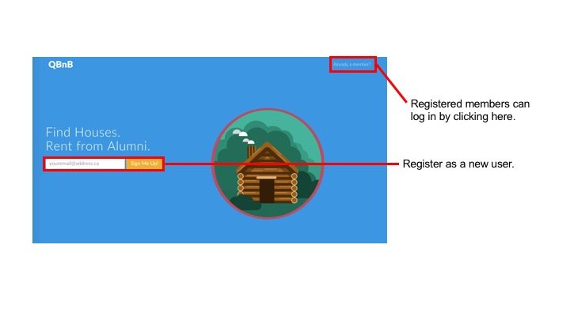

Log in screen for returning members:

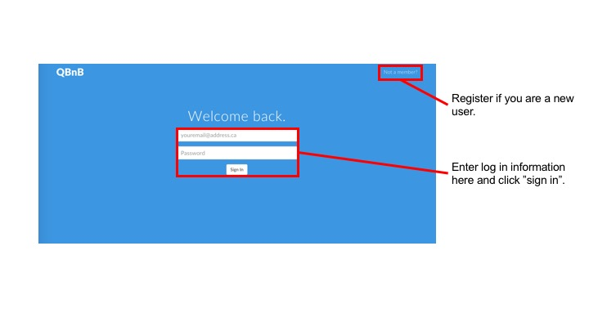

Sign up screen for new members:

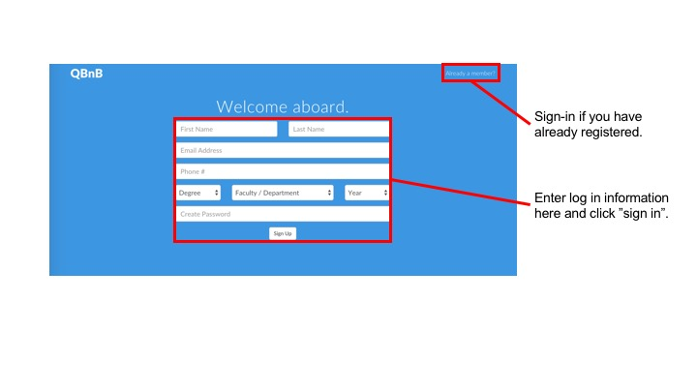

## Consumer Dashboard

Main Consumer page:

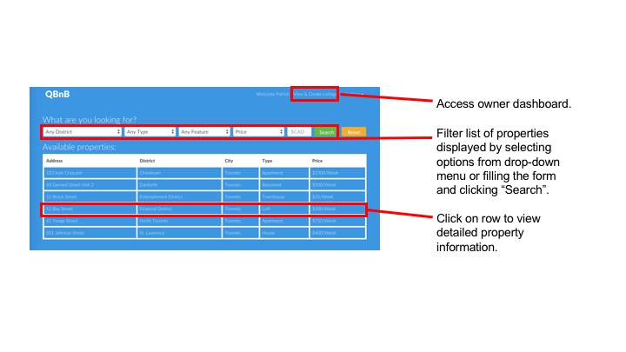

Update account settings or log-out:

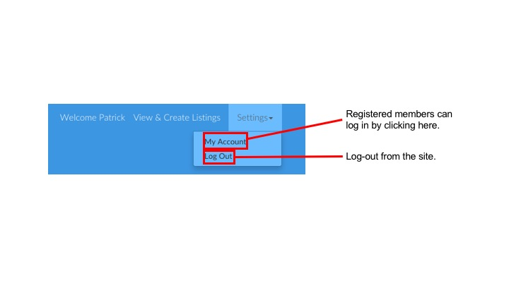

View extra details on selected property:

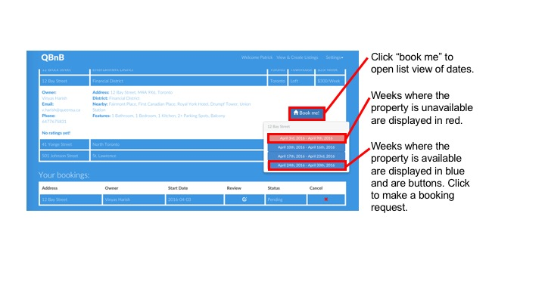

Property search resetting:

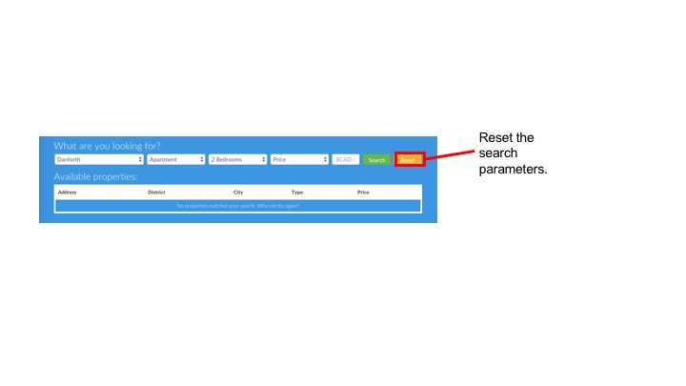

Manage your bookings:

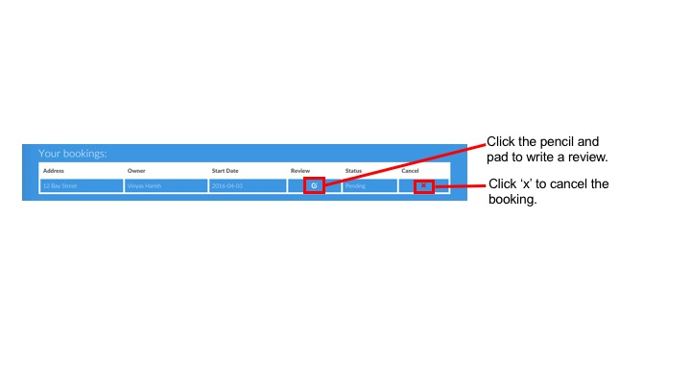

Make comments on your bookings:

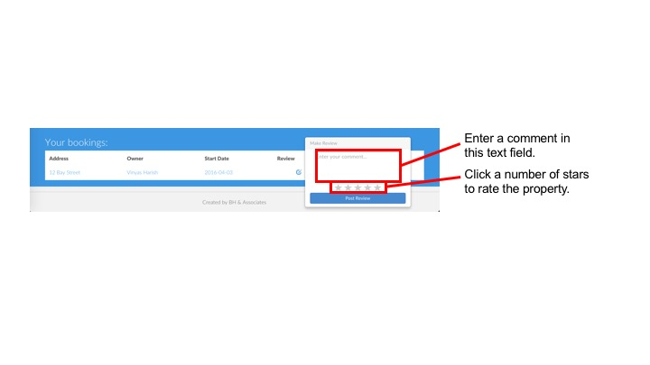

Update user account infotmation:

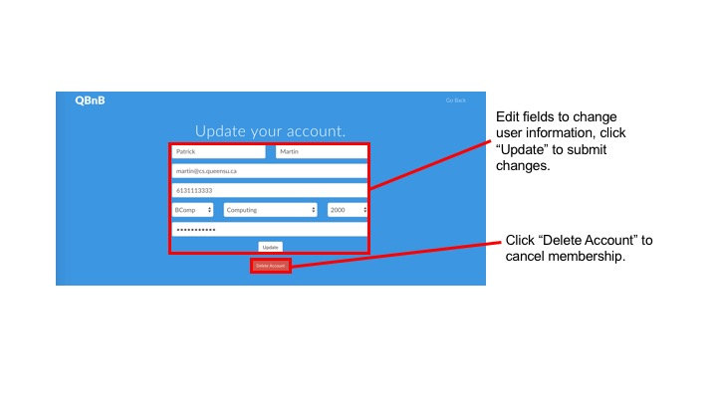

## Supplier Dashboard

Main Supplier page: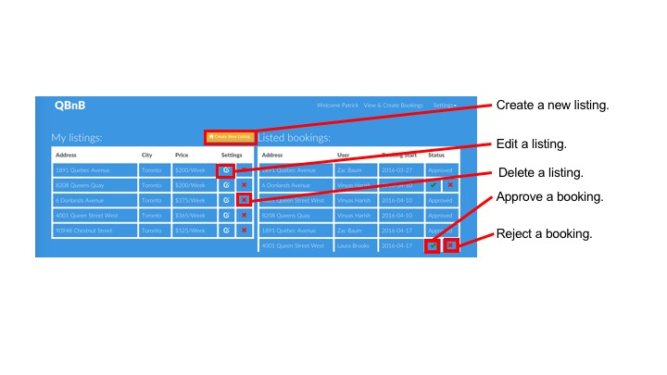

Replying to renter comments:

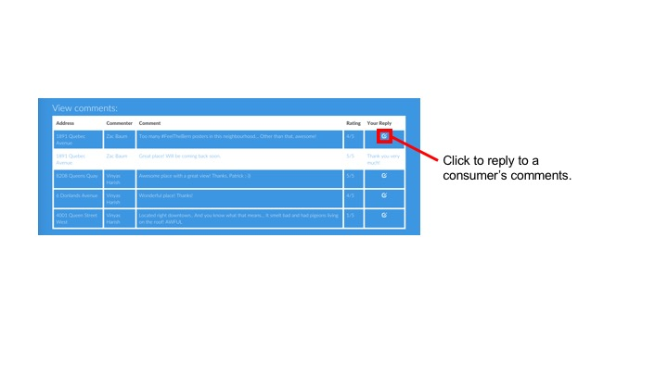

Making a reply to a comment:

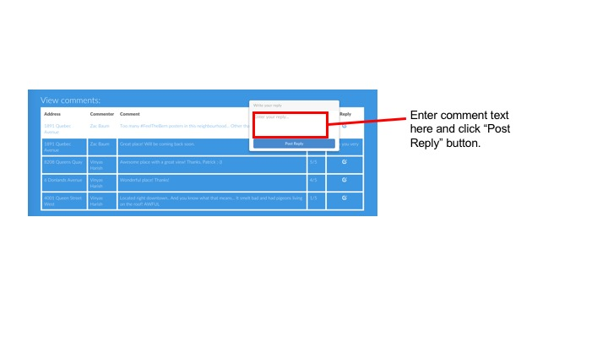

Creating a new property:

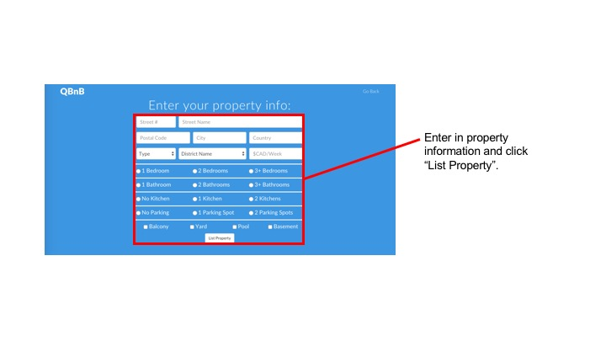

Updating an existing property:

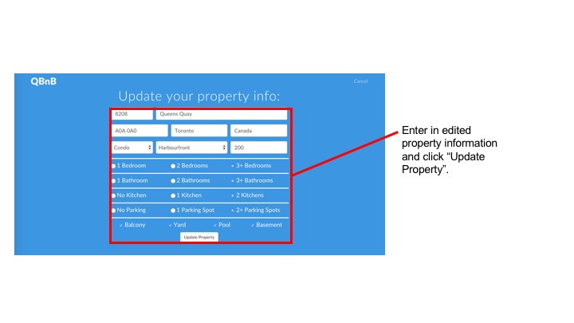

# Admin Guide

Accessing the Admin Dashboard:

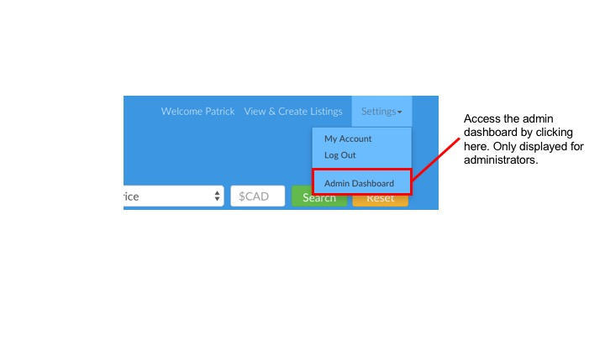

Deleting properties and users:

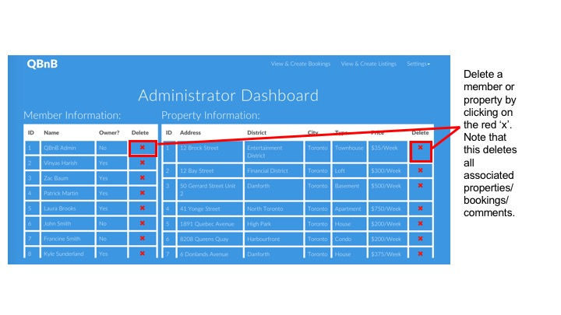

Viewing property information:

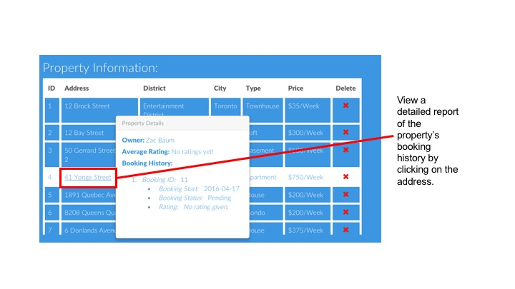

Viewing member information:

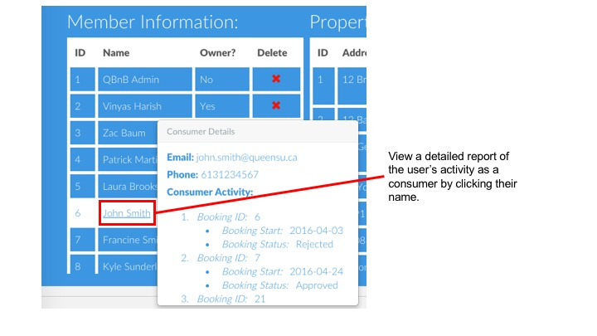

Viewing member owner information, if available.

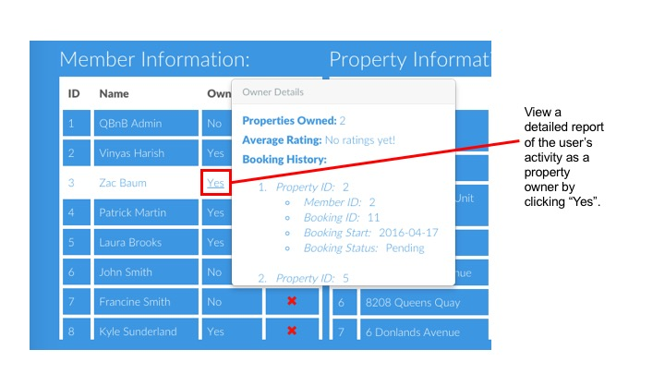

1. <http://www.oracle.com/us/products/mysql/overview/index.html> -- MySQL, a relational database creation and use tool [↑](#footnote-ref-1)
2. <https://products.office.com/en-ca/visio/flowchart-software> -- Visio, a mediocre Microsoft Office product [↑](#footnote-ref-2)
3. <https://www.draw.io> -- draw.io, an interactive diagram designer [↑](#footnote-ref-3)
4. <https://github.com> -- Github, a git based version control and repository system [↑](#footnote-ref-4)
5. <https://getbootstrap.com> -- Bootstrap, an open-source web design framework [↑](#footnote-ref-5)
6. <https://jqueryui.com> -- JQuery, Interactions, effects, widgets and themes built with Javascript [↑](#footnote-ref-6)
7. <https://atom.io> -- Atom, text editor [↑](#footnote-ref-7)
8. <https://www.sublimetext.com/> -- Sublime Text 2, text editor [↑](#footnote-ref-8)
9. <https://www.google.com/chrome> -- Google Chrome, web browser [↑](#footnote-ref-9)
10. <https://www.wikiwand.com/en/Usage_share_of_web_browsers> -- Web browser share among international users [↑](#footnote-ref-10)
11. <https://www.apachefriends.org/index.html> -- XAMMP, local PHP Development Server [↑](#footnote-ref-11)
12. <https://www.phpmyadmin.net/> -- PHPMyAdmin, database administrative tools [↑](#footnote-ref-12)
13. <https://www.codecademy.com/learn> -- Codeacademy, online programming tutorials [↑](#footnote-ref-13)
14. <https://www.w3schools.com> -- W3Schools, the worlds largest web developer site [↑](#footnote-ref-14)
15. <https://stackoverflow.com/> -- StackOverflow, a collaborative question and answer site for programmers [↑](#footnote-ref-15)
16. <https://slack.com> -- Slack, a messaging application for teams [↑](#footnote-ref-16)
17. Graham, you tha real MVP. [↑](#footnote-ref-17)